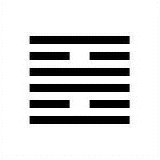
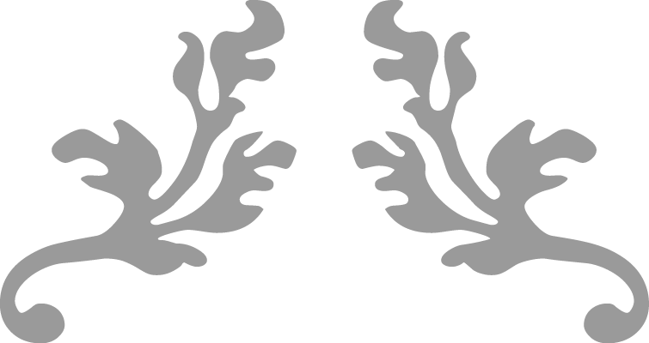
30- Fire/Brightness
“The upper canon demonstrates the yin-yang principle in natural phenomena, starting with Qian (1) and Kun (2) and ending with Kan (29) and Li (30). The four gua have special significance…Qian and Kun are Heaven and Earth and Kan and Li are the sun and the moon.”
Master Alfred Huang, “The Complete I Ching” (p. 256)



Yijing Project- Notes
  - Casting 30-Li- Fire for
  - April 18th through April 24th, 2021
Cyndi Clark | Yijing Project | 2021

Hexagram 30- Li- Fire, Changing lines- 4 & 5

Trigrams: Li-Fire over Li-Fire
Care of the cow brings good fortune. (Wilhelm-Baynes, online)
That which is bright rises twice:
The image of FIRE.
Thus the great man, by perpetuating this brightness,
Illumines the four quarters of the world.
Each of the two trigrams represents the sun in the course of a day. The two together represent the repeated movement of the sun, the function of light with respect to time. The great man continues the work of nature in the human world. Through the clarity of his nature he causes the light to spread farther and farther and to penetrate the nature of man ever more deeply.
Cow symbolizes docile/compliance; finding one’s place in the world and fitting into it; also nurturance- cows can be a source of income or livelihood; this could also mean after some turbulence and injury, caring for the things that will sustain is indicated. With the lines, discard impetuousness; adopt a nonjudgmental view of the situation to adapt to your position with clarity, resolve, and good cheer. Notice the old way didn’t work for anyone.
- Line 4: “A story used to explain this gua says that once there was an old king who suddenly passed away and a young king was crowned. Power struggles followed. The dark forces would flare up, die down, and be discarded. The line shows that in the course of life brightness may arise suddenly and the die out as quickly. One should be intelligent and wise enough to deal with the varying course of life.” (Huang, p. 260) {restlessness that consumes energy too rapidly and comes to nothing}
- Line 5: A yin element in a yang place; it’s a good placement, yet too weak to have influence, because superiors and inferiors exert strong pressure, which leads to a general bad attitude and frustration; if one is caught in the middle like this and walks the middle, there can still be good fortune. Adopt a more positive attitude so that life may be enjoyed. {the kind of stillness and clarity that lead to a true change of heart}
- 30’s opposite hexagram is 29- Darkness; it’s mutual is 28- Great Exceeding

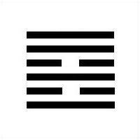

Hexagram 37- jia ren, The family/ household [Transformed Hexagram]

Trigrams: xun/Wind over Li/fire
“One who is injured abroad is sure to return home. Thus, after Brilliance Injured (previous hexagram 36), Household follows.” (Huang, p. 306)
“THE FAMILY shows the laws operative within the household that, transferred to outside life, keep the state and the world in order. The influence that goes out from within the family is represented by the symbol of the wind created by fire.”
Returning to home base to recover from harm brought by previous danger, disillusionment, lack of clarity, or darkness.
- Line 4: “The one at this place is gentle and modest; she is able to walk the central path and thus enrich the household. There is great good fortune.” (Huang, p. 311) {this has the feel of a mother/wife who makes the home a place of refuge}; line 4 in any hexagram is the position of “minister, or government official” whose responsibilities are to sublimate self interest to further the common good.
- Line 5: “The firm and yielding associate with each other on terms of mutual love. A harmonious family life will bring good fortune.” (Huang, p. 311) {this has the feel of a father who can be trusted}; line 5 in any hexagram is the position of the “head of household or a ruler, who is second only to heaven.
- 37’s opposite is 40- Relief; it’s mutual is also 64- Not yet fulfilled

On the concepts of Qian & Kun; Li & Kan [Preheaven/ PostHeaven; Heaven & Earth; Sun & Moon; the four cardinal directions: Qian- South; Kun- North; Li- West; Kan- East]
“Time carries energy; Space carries matter.” Li Se (see link)
“ Hex.29 is the contrast of 30, which is about using or absorbing things in order to find light and knowledge.
Hex.29 is adapting to things in order to find skill and wisdom”
The pit or danger as described by 29 can also be considered the fount of all knowledge- wisdom; hence 30- Brightness could be the light that shows it.
30: Catching the Bird of Brightness

Sun and Moon pair:
30
“Fire is an apt symbol for enlightenment because the power of truth is increase when it spreads to other minds. One candle lights another, and the amount of illumination is doubled without anyone’s light being diminished. For this reason, superior people do not hoard their knowledge, or their wisdom to receive it. In this way enlightenment eventually can reach “to the four corners of the world.” (Jack M. Balkin, “The Laws of Change, I Ching and the Philosophy of Life”, p. 346- Google Books version)
29
“Danger can clarify your thinking. It can help you understand yourself, what you truly care about, and what you must do. Thus, paradoxically, danger protects as well as threatens: Facing danger makes you stronger if you do not allow yourself to be overwhelmed by it.” (Balkin, ibid, p. 336)
Heaven and Earth pair:
1
Dynamic action backed with heaven’s blessing/ influence- right in time, flowing with the Dao. “The Book of Changes begins with the dynamic principle, which has four basic attributes. It is 1) fundamental,…2) successful,…3) beneficial,…4) persevering… These are the four virtues… The four Chinese words for these attributes (yuan, heng, li, zhen) are often used to represent the four seasons, or virtually anything that can be divided into four.” (Balkin, p. 119/120)

“Together, Qian and Kun symbolize the basic principles of alternation and change in the universe.” (p. 119)
2
The dark that complements the light; yielding that receives force; adjusting, acceptance and nurturing. The four virtues of yuan, heng, li, and zhen apply here, too- but perseverance of a mare (following, rather than leading) is acting in ways appropriate to the situation- adapting; dragon of heaven flies; mare roams the earth.
“Kun teaches us that one does not have to take the lead in order to have influence, one does not have to be dynamic in order to exercise power, one does not have to be arrogant in order to impress others, and one does not have to be first in everything in order to prevail in the end.” (Balkin, p. 130)
Direction: Southwest- seeking assistance from humility, devotion, cooperation, responsiveness; the opposite direction- Northeast might indicate avoiding arrogance, selfishness, indifference.

