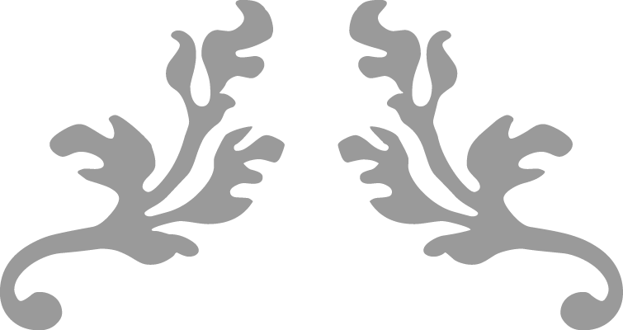
19- Approach
“This gua is very special. The four most auspicious virtues of yuan, heng, li, and zhen have been bestowed upon it. It expounds the principle of leadership.”
Master Alfred Huang, “The Complete I Ching” (p. 181)

Yijing Project- Notes
  - Casting 19- Approach for
  - April 11th through April 17th, 2021
Cyndi Clark | Yijing Project | 2021

Hexagram 19- Approach, Changing line- 1

Trigrams: Kun-receptive, Earth over Dui-lake or marsh
The hexagram is about good leadership and how to approach it. The lines explain actions that demonstrate the qualities of good or bad leadership, but as Master Huang explains in his commentary, this is the kind of leadership that takes hold after an old wrong is being made right. The hexagram before it, 18- Fixing what has been spoiled, sets the stage before a true leader or teaching can be laid out for the people. Wilhelm-Baynes translation uses the word “condescension” and it’s an important key to the meaning- in ancient times, this word did not have the same distasteful connotation as it does today. Rather than meaning looking down one’s nose at those thought to be inferior, it was a skill to be developed by one who is well placed in society to be able to place him/herself sincerely and respectfully in the shoes of the unprivileged as equal human beings.
Huang explains that this is an auspicious hexagram all the way around. It is special as the “… four most auspicious virtues of yuan, heng, li, and zhen are bestowed upon it”* See notes on pages 3&4 of attached document for discussion.
The story behind it is the overthrow of the Zhou tyrant; he couldn’t be reasoned with, so King Wen understood he had to be overthrown, but to do that, he needed the blessings of Heaven (mandate) and to develop an army. So, the sage recognizes when the tides have turned, along with the idea of inevitability- 19 is associated with the 12th lunar month of the year, which corresponds with January/February when one season is more obviously turning to the next, but also, one year has fully cycled and a new one is about to begin.
“Just as the lake is inexhaustible in depth, so the sage is inexhaustible in his readiness to teach mankind, and just as the earth is boundlessly wide, sustaining and caring for all creatures on it, so the sage sustains and cares for all people and excludes no part of humanity.” (Wilhelm Baynes online 19)
- Line 1: Nine at the beginning means joint approach. Perseverance brings good fortune. Commentary on the line: the sage recognizes when the tides have begun to turn; the picture of the hexagram contains the idea of the time of year when the spring season is assured, after the Winter solstice. “The good begins to prevail and to find response in influential circles. This in turn is an incentive to men of ability.” Though success is assured, if you don’t get carried away with what you are doing right now, there will be good fortune.
- 19’s opposite hexagram is 33- Retreat; it’s mutual is 24- Returning

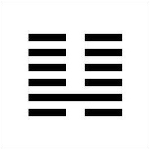

Hexagram 7- Army, Multitude [Transformed Hexagram]

Trigrams: Kun-receptive, Earth over Kan- the Abysmal, Water

Ground water stored in the earth. Comparison to how a country’s army is kept within the mass of people- invisible until it is needed. Danger inside and obedience outside. [yang line in second place can indicate a commander- not the emperor, but the general= since it’s in the lower trigram] “Without discipline, nothing can be accomplished, but this discipline must not be achieved by force. It requires a strong man who captures the hearts of the people and awakens their enthusiasm. In order that he may develop his abilities he needs the complete confidence of his ruler, who must entrust him with full responsibility as long as the war lasts.” [resorting to war, though should not become an addiction] the justification of war that will win popular support because it is around a cause that people can rally around or a lack of unity and purpose will lead to destruction and loss; the passion of this kind of unity though cannot lead to “anything goes”; the so-called “rules of war” must be followed. “When danger threatens, every peasant becomes a soldier; when the war ends, he goes back to his plow.” “Only a people economically strong can be important in military power. Such power my therefore be cultivated by improving the economic condition of the people and by humane government. Only when there is this invisible bond between government and people, so that the people are sheltered by their government as ground water is sheltered by the earth, is it possible to wage a victorious war.”
- Line 1: Order is imperative in the beginning of a campaign. “just and valid cause must exist, and the obedience and coordination of the troops must be well organized, otherwise the result is inevitably failure.”
- 7’s opposite is 13- Seeking Harmony; it’s mutual is also 24- Returning

On the concepts of yuan, heng, li, and zhen:
19 contains the four central auspicious concepts, as did last week’s reading 17-Sui, Following.
LiSe -eminent, expansion, harvest, divination
Yuan (eminent- the first, the fundamental, spring; sowing the original virtues; opening, new fields, pathways, creative potential and material to work with it, even if resources are still small, the can be made use of; no fear in investing)
Heng (expansion- growing crops- summer- offering and receiving, abundance with an attitude of giving/sacrifice; confidence; expect that things will go well)
Li (harvest, fruitful- a return on time and energy invested; profitable)
Zhen (this is asking a question AND getting a definite divine reply)
Yifa Society:
Taken together, yuan heng li zhen is typically translated as “sublime celestial forces in motion”
Separately, yuan heng: ritual/sacrifice/offering perform correctly; also a broad and easy path
Some traditions use this as a kind of mantra; a calling down of celestial forces and powers through yuan- ritual- the invocation; performance of the right, heng; li, receiving a response (the ritual bring harmony between the practitioner and the universe); zhen is the application of the response- embodying it; listening to the advice or message given. 19 is one of only four hexagrams in the Yi jing that carries these four facets of virtue and is thought to be a definite message from the universe: maybe divine intervention of some sort. Prayers said, definite answer. (Yifa Society)
Yifa Society:
Taken together, yuan heng li zhen is typically translated as “sublime celestial forces in motion”
Separately, yuan heng: ritual/sacrifice/offering perform correctly; also a broad and easy path
On the season of “clear and bright” Qing Ming 5th solar term New moon (return)
As I release these notes into the windy interwebs, the moon is waxing toward full, and we are a few days into “Qing ming” time of year, but when I cast the oracle on Sunday, it was the actual day of the new moon April 11, which corresponds to the hexagram 24- Returning. Both the original and transformed hexagrams for the reading are associated through mutuality with 24. Sometimes, this oracle blows my mind. This is one such time.
Other odds and ends (that are probably in the article I am posting this week, but it’s all connected!
Very cool article on the clear and bright season from the feng shui perspective is linked.
Although the QingMing festival day has already passed for 2021, here is an article on how it is traditionally celebrated.:
Traditions include: sweeping, cleaning loved ones’ tombs; offering joss paper money, incense, or food; talking a stroll in the country and flying kites.
History
Willow tree spring traditions, including QingMing: [in both hexagrams 19 and 7, the finest leadership involves flexibility, humility, perceptiveness, and a certain degree of magical prowess, or skill at influencing- bending without breaking the wills of others to follow them.]
“In China, Willow is a symbol of immortality and rebirth. In the other parts of the world the willow trees feature in mythology and literature as a symbol of the moon, water, grief, healing, everlasting life and often symbolizes grief. The willow tree's association with the moon comes from the lunar influence on water, including tides.

As if it was bowing, a willow tree symbolizes humility. Willow trees are also associated with mysticism and superstition.

A tradition for the Qingming Festival (Tomb Sweeping Day), which stretches back more than 1000 years, is wearing a garland made from willow twigs. People also hung willow under their roofs and windows to prevent ghosts and evil spirits from entering the house, as it was believed during the period it was held that ghosts walked the earth

In China, presenting a twig of willow to another person is also a way of expressing that you want them to stay. The word Mandarin word for willow is liu, the same as the word for stay, although they are pronounced with different tones.”
Cross cultural willow tree traditions:
The Chinese custom has parallels to the Christian observance of Palm Sunday, which falls on Sunday 12th April (2020) when willow crosses are hung in homes. In Celtic mythology willows were connected to death Goddesses, and it’s intrinsically linked to death as an emblem of grief - after all it’s called the ‘weeping willow’ due to the weeping display of branches that drupe downward. Oft seen in graveyards as when it rains the tree is said to weep tears when the long droopy leaves are soaked.

Druid folklore speaks to the creation of mankind, hatched from two scarlet red eggs hidden in a willow tree - one egg formed the sun and the other the Earth. And in Celtic art, the tree of life is often shown as a willow tree, with the tree’s seasonal cycles linked to death, rebirth and growth.

Willow folklore is rooted in witchcraft, with the turn of phrase Wicca & Wicce linked to the malleable fashion a willow branch can be bent or manipulated - akin to magical prowess of witches and wizards. And of course Willow is the wood of choice, favoured to fashion divining rods. While the wood of the willow when displayed inside or outside a home are also said to protect against evil. Willow tree typically grows in yin damp conditions, often along river beds or ponds.

Once again the Chinese and Celtic cross cultural story weaves a link with Willow, the 5th month of the Celtic Zodiac is the willow symbol, and Qing Ming is the 5th solar term! Celtic astrology’s sign of the willow tree is April 15th - May 12.”

